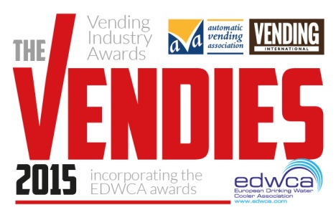
The Vendies 2015
Entry Form
Manufacturer Awards

Section 1: Your details (simply type over the grey area)

First name |  | Surname
Job title
Company
Address
 |  | Postcode
Telephone
E-mail

Section 2: Categories: (tick all that apply)

Best Machine Innovation 2015
Best Payment System 2015

Section 3: Supporting material

Please detail the reasons why you feel your company/the company you are nominating should win an award for their outstanding machine innovation or payment system. You may wish to include examples of new technology, innovation, aesthetics and ease of use.

Best Machine Innovation  Manufacturer:  Product: |  | Insert company logo below as hi res jpeg (300dpi or min 1mb)
Entry statement (max 500 words):

Entries must be received by March 27th 2015
Please insert one hi res image that shows the machine to its best advantage. You can do this by clicking on the icon below – this will then allow you to attach an image from file.
The Vendies 2015
Entry Form
Manufacturer Awards

The Vending Industry Awards
Best Payment System  Manufacturer:  Product: |  | Insert company logo below as hi res jpeg (300dpi or min 1mb)
Entry statement (max 500 words):

Entries must be received by March 27th 2015
Please insert one hi res image that shows the payment system to its best advantage. You can do this by clicking on the icon below – this will then allow you to attach an image from file.

Thank you for entering The Vendies 2015!
Please return completed forms to gmoore@datateam.co.uk by Friday 27th March 2015.
If you have any queries, please do not hesitate to contact me on 01622 699183.

Good luck!

Bryony Andrews
Features Editor
Vending International
www.thevendies.co.uk
2015 Entry Form
Manufacturer Awards

