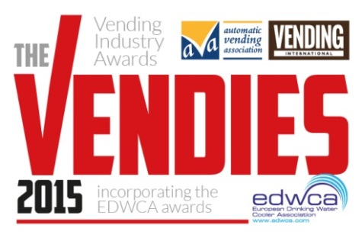
The Vendies 2015
Entry Form
EDWCA Awards

Section 1: Your details (simply type over the grey area)

First name |  | Surname
Job title
Company
Address
 |  | Postcode
Telephone
E-mail

Section 2: Categories: (tick all that apply)

Best Environmental Initiative

Best Innovation

Water Distributor of the Year

Best Investor in their People

Section 3: Supporting Material
Please explain the reasons you feel your product/company should win the award.

Best Environmental Initiative  Company name:  Project:  - Give details on how your company demonstrates good environmental and sustainability practice in the last twelve months. Please include any supporting documentation.  - Show how you engage your staff, suppliers, customers and community in your initiative.  - How has your initiative been beneficial to the environment?  - Has the initiative shown cost benefits or savings to your organisation? Include details of any other successes to your business from this project. |  | Insert company logo below as hi res jpeg (300dpi or min 1mb)
Entry Statement

Best Innovation
Product:
Manufacturer:
- Commercial relevance of the development and actual or projected commercial success.
- Describe the differences that this innovation has made upon your business, customers and industry?
- How has your initiative been beneficial to the environment?
- Show how you engage your staff, suppliers, customers and community in your initiative.

Entry Statement

Water Distributor of the Year  Company name:  - How does your business contribute and/or adapt to the changing needs of our industry?  - Show how your company has adapted to accommodate more demanding and diverse consumer trends.  - Show how you invest, engage and motivate your people at all levels.  - Show how your company continually meets the expectations of your customers. Please include a customer testimonial. |  | Insert company logo below as hi res jpeg (300dpi or min 1mb)
Entry Statement

Best Investor in their People  Company name:  - Please outline the details of your reward and recognition strategy and how it is implemented.  - Outline how your reward and recognition strategy is aligned with your organisations values, culture and ambitions.  - Please give details of the successes, giving examples.  - Describe how you plan to continually improve and sustain your strategy in the future. |  | Insert company logo below as hi res jpeg (300dpi or min 1mb)
Entry Statement

Thank you for entering The Vendies 2015!
Please return completed forms to gmoore@datateam.co.uk by Friday 27th March 2015.
If you have any queries, please do not hesitate to contact me on 01622 699183.

Good luck!

Bryony Andrews
Features Editor
Vending International
www.thevendies.co.uk
2015 Entry Form
EDWCA Awards Entry Form

